STATIONERY (for the year)
Stationery and Textbooks (2022)
̴ Grade 10 ̴

Blou penne | 8
Potlode 2H (vir Meetkunde) | 2
Potlode HB | 6
Uitveërs | 2
Liniaal 30cm | 1
Pritt glue stick 43g | 4
Skerpmaker met houer | 1
Skêr (links- of regshandig) | 1
Gekleurde penne (12 pak) | 1
Highlighters (6 pak) | 1
Inkleurpotlode (12 pak) | 1
Exam pad folder (opsioneel) | 1
Exam pad 100 sheets (punched) | 10
Ring-reinforcements (250’s) | 4
Casio FX-82ZA Plus (or newer) Scientific Calculator | 1
Helix Oxford set of Mathematical Instruments (Passerstel) | 1
Dagboek (huiswerk / toetsdatums / ens.) | 1

SKRIFTE
Rexel 5 Part Trans File x 6 (alle formele assesserings word hierin gehou – een per vak) | 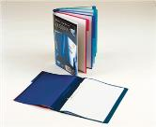
AFRIKAANS
A4 1 Quire Counter Book Feint & Margin 288 pages | 1
ENGLISH
A4 25mm 2 D-Ring Binder File | 1
MATHEMATICS
A4 3 Quire Counter Book Feint & Margin 288 pages | 1

PHYSICAL SCIENCE
A4 Lever arch file | 1
File dividers 10 tab Plain | 1
CAT (Computer Applications Technology)
A4 Lever arch file | 1
File dividers 10 tab Plain | 1
Memory stick | 1
LIFE SCIENCE
A4 Lever arch file | 1
File dividers 10 tab Plain | 1
ACCOUNTING | 1
A4 Lever arch file | 1
File dividers 10 tab Plain | 1
HISTORY | 1
A4 Lever arch file | 1
File dividers 10 tab Plain | 1
IGO (Ingenieursgrafika & Ontwerp) / EGD (Engineering Graphic and Design)
Scola Tek Uitgewers in Northcliff het vir ons ‘n Baken Akademie Stel help saamstel wat al die gereedskap bevat vir VOO fase (Gr 10 – Gr 12). Die Stel bevat ook die regte sakke om toerusting te beskerm.

Volg die volgende skakel vir die volledige stel: https://scolatek.com/product/special-kit-for-bakenakademie/

Indien daar apart komponente aangeskaf wil word, kan die volgende lys gebruik word:
A3 Ringbinder File | 1
A3 Flip File | 1
A3 tekenbord (Navigator Board) | 1
Large Padded Bag (Vir teken bord en lêers) | 1
Mini Padded Bag (om toerusting veilig te hou) | 1
30°/60° driehoek | 1
45° driehoek | 1
Skaal liniaal met skale 1:1, 1:2, 1:5, 1:10 en 2:1 (Engineering Ruler) | 1
20 cm of 15 cm Liniaal | 1
Sirkelstensil | 1
Uitveërplaatjie / Eraser shield | 1
Gradeboog | 1
Passer met 0.5 drukpotlood hegstuk | 1
Drawing compass (with adjustment wheel – springbow) & measuring compass 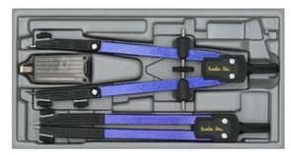 | 1
5mm Drukpotlood 2H en 4H | 1
Masking tape 5mm of 10mm | 1
Technical stencil – Nuts and Bolts | 1
Technical stencil – Ellipse / Oval | 1
Technical stencil – Architectural (skaal 1:50) | 1
Technical Stencil – Orthographic Projection Symbols | 1
Flexi Curve ruler | 1
Set of 3 French Curves | 1
Eraser | 1
MATHEMATICAL LITERACY | 1
A4 Lever arch file | 1
File dividers 10 tab Plain | 1
LIFE ORIENTATION | 1
A4 Exercise Book Feint Margin 72 pages | 1
VISUAL ARTS
A3 Visual diary(Black or White pages | 1
Drawing Pencils set | 1
Oil Pastels | 1
Charcoal drawing sticks | 1
Acrylic paint (Red, Blue, Yellow, White, Black) | 1
Basic paint brush set | 1

EXTRA
A4 White copy printer paper - Riem (2 per kwartaal) | 8
Tissues (1 boks per kwartaal) | 4
Boksie pleisters (sonder prentjies) | 1

TEXTBOOKS (Gr 10 – 2021)
AFRIKAANS:  Afrikaans Sonder Grense. Eerste Addisionele Taal | ISBN:  0-636-12865-2 /  978-0-636-12865-1
Letterkunde bundel
Te Koop by die skool teen R150

AFRIKAANS:  Veldiep  Fanie Viljoen | ISBN:  9780624085379
ENGLISH:  St Mary’s Interactive Experience Learner Book | ISBN:  9781920391447  The school will obtain from supplier and invoice parents. | 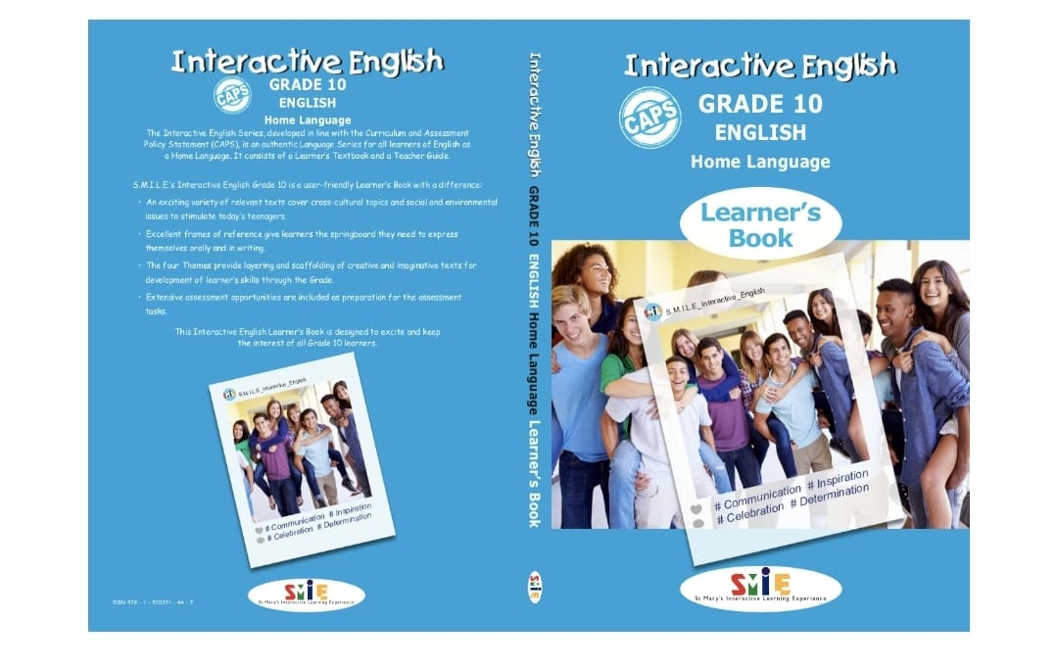
ENGLISH:  Macbeth (No Fear Shakespeare) | ISBN:  9781586638467 | 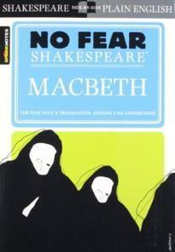
ENGLISH:  The Mark by Edith Bulbring | ISBN:  9780624068815 | 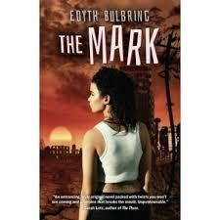

ENGLISH:  Poems from all over –  Anthology  OXFORD | ISBN:  9780199079636  e-book:  9780190414368 | 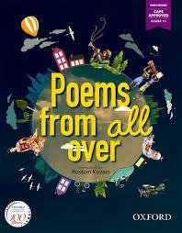
MATHEMATICS:  Maths Handbook and Study Guide Gr 10 - Kevin Smith | ISBN:  9780981437026 | 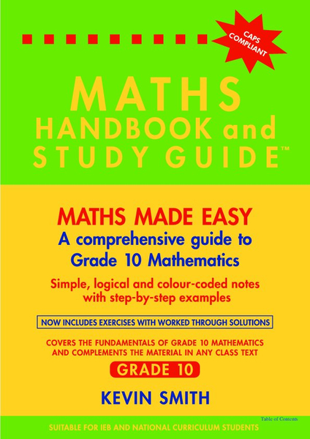
PHYSICAL SCIENCE (Physics):  DocScientia Physics Grade 10 Textbook and workbook (2020 Edition) | Order directly from Doc Scientia. Order forms are available on:  https://www.docscientia.co.za/index.php/home-page  Note: Both books can be ordered as a bundle. Both books are available in colour if the student prefers a colour textbook. | 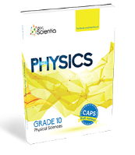
PHYSICAL SCIENCE (Chemistry):  DocScientia Chemistry Grade 10 Textbook and Workbook (2020 Edition) | Order directly from Doc Scientia. Order forms are available on:  https://www.docscientia.co.za/index.php/home-page  Note: Both books can be ordered as a bundle. Both books are available in colour if the student prefers a colour textbook. | 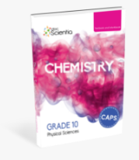

CAT:  Computers, Part of Your Life Grade 10  Learner’s Book Second Edition | ISBN:  978-0-9947032-0-0 | 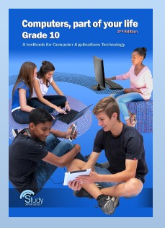
LIFE SCIENCES:  The Answer Series Life Sciences 3 in 1.  Grade 10 CAPS | ISBN:  978-1-920297-85-5 | 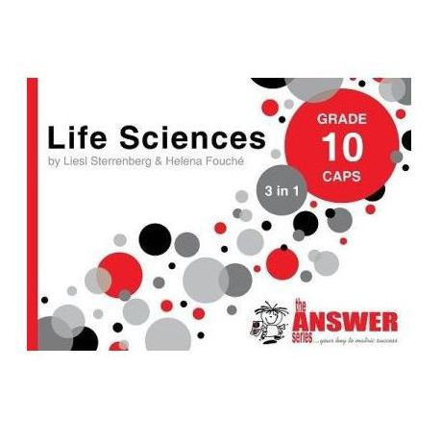
ACCOUNTING:  New Era Accounting Grade 10  Learner’s book | ISBN:  978-1-92032-140-6 | 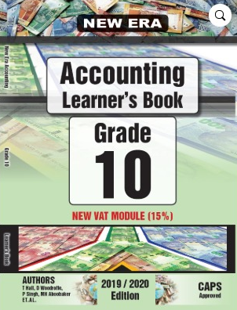
ACCOUNTING:  New Era Accounting grade 10  Exercise book 1 and 2 | ISBN:  978-1-92032-181-9 | 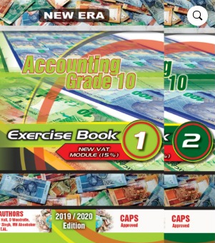
ACCOUNTING:  Advanced Accounting workbook Grade 10 | ISBN:  978-0-9802730-2-1 | 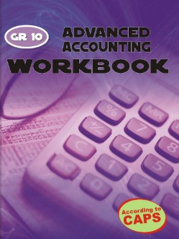
IGO:  JPEGDIGO Engineering Graphics and design Gr 10 workbook. (A3) 8th Edition | ISBN:  978-1-77633-218-2 | 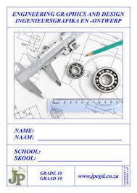
MATHEMATICAL LITERACY:  The answer series. Mathematical Literacy Grade 10 CAPS | ISBN:  978-1-920297-81-7 | 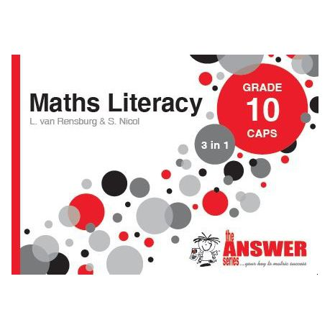
LIFE ORIENTATION:  Oxford Successful LO  Grade 10 | ISBN  9780199045273 | 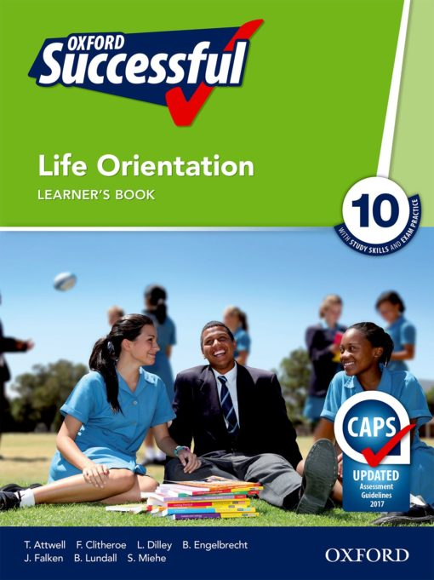
VISUAL ART  Visual Arts Grade 10 Learner Guide | 9781920364649 | 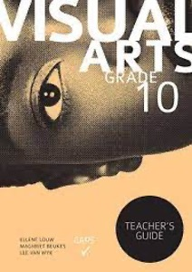
HISTORY  FOCUS History | ISBN  978-0-636-12740-1 | 