STATIONERY (for the year)
Stationery &
Textbooks 2022
̴ Grade 8 ̴

Blue pens | 8
Pencils 2H (for Geometry and Technology) | 2
Pencils HB | 6
Erasers | 2
Ruler 30cm | 1
Pritt glue stick 43g | 4
Sharpener with shavings holder | 1
Scissor (left or right handed | 1
Coloured pens (12 pack) | 1
Highlighters (6 pack) | 1
Colouring pencils (12 pack) | 1
Exam pad folder (optional) | 1
Exam pad 100 sheets (punched) | 10
Ring-reinforcements (250’s) | 3
Casio FX-82ZA Plus (or newer) Scientific Calculator | 1
Helix Oxford set of mathematical Instruments (Passerstel) | 1
Diary (homework / test dates / etc) | 1
Flip File | 1

SKRIFTE
AFRIKAANS
A4 3 Quire Counter Book Feint & Margin 288 pages | 1
ENGLISH
A4 3 Quire Counter Book Feint & Margin 288 pages | 1
A4 25mm 2 D-Ring Binder File | 1
A4 Exercise Book Feint & Margin 72 pages (English Assessment ) | 1
MATHEMATICS
A4 3 Quire Counter Book Feint & Margin 288 pages | 1
NATURAL SCIENCES
Use DocScientia workbook | -
TECHNOLOGY
Technical drawing compass
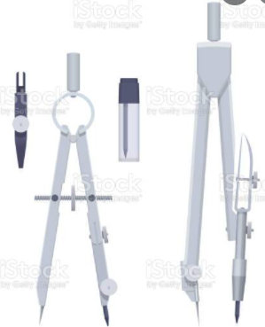

SOCIAL SCIENCES
A4 1 Quire Counter Book Feint & Margin 96 pages (Geskiedenis) | 1
A4 1 Quire Counter Book Feint & Margin 96 pages (Geografie) | 1
EMS (Economic Management Sciences)
A4 Exercise Book Feint & Margin 72 pages | 1
LIFE ORIENTATION
A4 Exercise Book Feint & Margin 72 pages | 1

EXTRA
A4 White copy printer paper - ream (2 per quarter) | 8
Tissues (1 box per quarter) | 4
Box of adhesive bandages (without pictures) | 1

TEXTBOOKS (Gr 8 – 2021)
AFRIKAANS:  Afrikaans Sonder Grense. Graad 8 Leerderboek | ISBN:  9780636119789 | 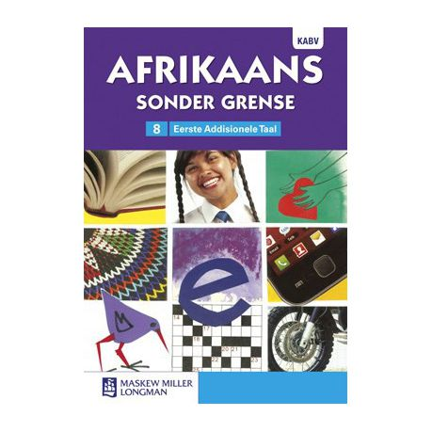
AFRIKAANS:  Afrikaans Sonder Grense. Graad 8 Leesboek | ISBN  9780636146211
AFRIKAANS:  Blitz Afrikaans Gr 4 – 12  (reeds aangekoop in 2019) | Contact Suerette Maartens to order  083 791 1831
AFRIKAANS:  Raaiselster  Troula Goosen | ISBN:  9780798178976  Epub ISBN:  9780798178983
ENGLISH:  St Mary’s Interactive English, Grade 8 Home Language, Learners Book | ISBN:  978-1-920391-50-8  (School will obtain books directly from the supplier and invoice parents. ) | 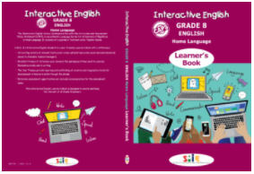

ENGLISH:  Child in Darkness  Robert Hill | ISBN:  9780624020066
MATHEMATICS:  Maths Handbook and Study Guide Grade 8 | ISBN: 9780981437040 | 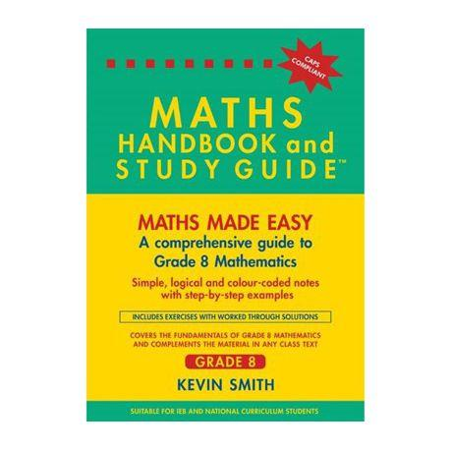

NATURAL SCIENCES:  DocScientia Natural Sciences  Grade 8 Textbook & Workbook  2020 Edition |  | 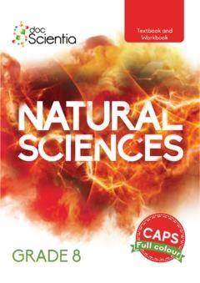
SOCIAL SCIENCES:  Platinum Social Sciences Grade 8  Learner’s Book | ISBN:  9780636141360 | 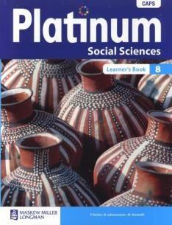
SOCIAL SCIENCES:  Oxford Secondary Atlas for South  Africa Grade 7 – 12  (to be used from grade 7 to grade 12 – Afrikaanse weergawe  aangekoop in 2019 is voldoende) | ISBN:  9780199070398 | 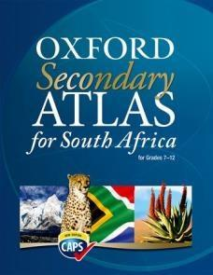
TECHNOLOGY:  JPEG DIGO Engineering Graphics  Grade 8 Workbook | ISBN:  9780639956800 | 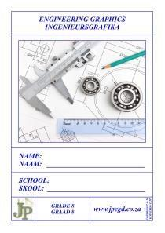
EMS:  Accounting: Leaner’s work book  Wamark Publishers | ISBN:  9780958501743 | 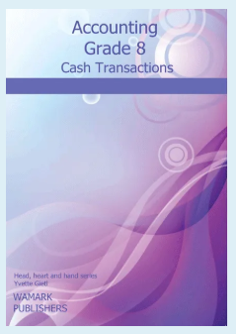
EMS:  Business studies: Classroom Masters | ISBN:  9780987008152 | 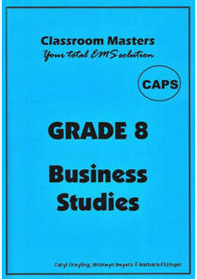
LIFE ORIENTATION:  Oxford Life Orientation  Headstart | ISBN  9780199047734 | 