STATIONERY (for the year)
Stationery and Textbooks (2022)
̴ Grade 12 ̴

Blou penne | 8
Potlode 2H (vir Meetkunde) | 2
Potlode HB | 6
Uitveërs | 2
Liniaal 30cm | 1
Pritt glue stick 43g | 4
Skerpmaker met houer | 1
Skêr (links- of regshandig) | 1
Gekleurde penne (12 pak) | 1
Highlighters (6 pak) | 1
Inkleurpotlode (12 pak) | 1
Exam pad folder (opsioneel) | 1
Exam pad 100 sheets (punched) | 10
Ring-reinforcements (250’s) | 4
Casio FX-82ZA Plus (or newer) Scientific Calculator | 1
Helix Oxford set of Mathematical Instruments (Passerstel) | 1
Dagboek (huiswerk / toetsdatums / ens.) | 1

SKRIFTE
Rexel 5 Part Trans File x 6 (alle formele assesserings word hierin gehou – een per vak) | 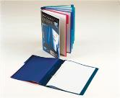
AFRIKAANS
A4 1 Quire Counter Book Feint & Margin 196 pages | 1
ENGLISH
A4 25mm 2 D-Ring Binder File | 1
WISKUNDE
A4 3 Quire Counter Book Feint & Margin 288 pages | 1

FISIESE WETENSKAPPE
A4 Lever arch file | 1
File dividers 10 tab Plain | 1
CAT (Computer Applications Technology)
A4 Lever arch file | 1
File dividers 10 tab Plain | 1
Memory stick | 1
LEWENSWETENSKAPPE
A4 Lever arch file | 1
File dividers 10 tab Plain | 1
REKENINGKUNDE | 1
A4 Lever arch file | 1
File dividers 10 tab Plain | 1
GESKIEDENIS | 1
A4 Lever arch file | 1
File dividers 10 tab Plain | 1
IGO (Ingenieursgrafika & Ontwerp) / EGD (Engineering Graphic and Design)
Scola Tek Uitgewers in Northcliff het vir ons ‘n Baken Akademie Stel help saamstel wat al die gereedskap bevat vir VOO fase (Gr 10 – Gr 12). Die Stel bevat ook die regte sakke om toerusting te beskerm.

Volg die volgende skakel vir die volledige stel: https://scolatek.com/product/special-kit-for-bakenakademie/

Indien van die toerusting REEDS besit word, maak gebruik van die volgende lys om toerusting aan te vul. Onthou ook daar moet elke jaar ‘n A3 Ringbinder aangeskaf word vir die PAT dokumente.
A3 Ringbinder File | 1
A3 Flip File | 1
A3 tekenbord (Navigator Board) | 1
Large Padded Bag (Vir teken bord en lêers) | 1
Mini Padded Bag (om toerusting veilig te hou) | 1
30°/60° driehoek | 1
45° driehoek | 1
Skaal Liniaal met skale 1:1, 1:2, 1:5, 1:10 en 2:1 (Engineering Ruler) | 1
20 cm of 15 cm Liniaal | 1
Sirkelstensil | 1
Uitveërplaatjie / Eraser shield | 1
Gradeboog | 1
Passer met 0.5 drukpotlood hegstuk | 1
Drawing compass (with adjustment wheel – springbow) & measuring compass 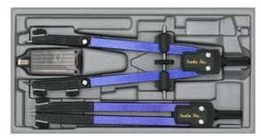 | 1
5mm Drukpotlood 2H en 4H | 1
Masking tape 5mm of 10mm | 1
Technical stencil – Nuts and Bolts | 1
Technical stencil – Ellipse / Oval | 1
Technical stencil – Architectural (skaal 1:50) | 1
Technical Stencil – Orthographic Projection Symbols | 1
Flexi Curve ruler | 1
Set of 3 French Curves | 1
Eraser | 1
WISKUNDIGE GELETTERDHEID | 1
A4 Lever arch file | 1
File dividers 10 tab Plain | 1
LEWENSORIëNTERING | 1
A4 2D-Ring binder / mini lever arch file | 1
File dividers 5 tab Plain | 1
VISUAL ARTS
A3 Visual diary(Black or White pages | 1
Drawing Pencils set | 1
Oil Pastels | 1
Charcoal drawing sticks | 1
Acrylic paint (Red, Blue, Yellow, White, Black) | 1
Basic paint brush set | 1

EKSTRA
A4 White copy printer paper - Riem (2 per kwartaal) | 8
Tissues (1 boks per kwartaal) | 4
Boksie pleisters (sonder prentjies) | 1

HANDBOEKE (Gr 12 – 2022)
AFRIKAANS:  Onderwerled  Fanie Viljoen | ISBN:  978-0-624-04669-1
AFRIKAANS:  Via AfR EAT  Leerderboek | ISBN: 9781415422779
AFRIKAANS:

Letterkunde Bundel te koop by die skool teen R150.
ENGLISH: NOVEL  Diamond Boy – Michael Williams  OXFORD (This edition has many useful notes in the side-lines of the story.) | ISBN:  978019 904904 2  e-book:  978019907800 4
ENGLISH : DRAMA  Pygmalion – George Bernard Shaw |  | Any version of the book is acceptable, a free online version is available from the Spark Notes website

ENGLISH: POETRY  Poems from all over –  Anthology  OXFORD | ISBN:  9780199079636  e-book:  9780190414368 | 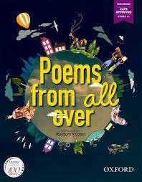
ENGLISH: Language usage  SMILE | ISBN:  9781920391485  School has procured these textbook already. Parents will be invoiced. | 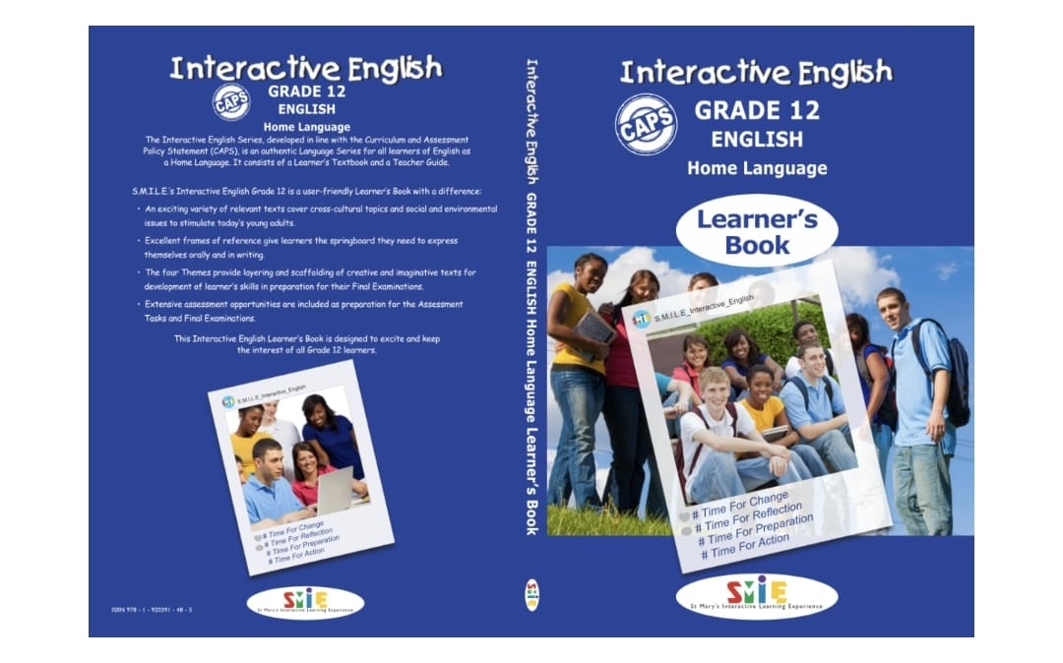
WISKUNDE:  Die Antwoord Reeks: Wiskunde Gr 12 KABV 2 in 1 | ISBN:  9781920568696 | 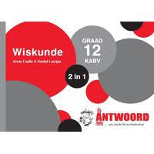
WISKUNDE:  Mind Action Series: Wiskunde Meetkunde Werkboek Gr 12 | ISBN:  9781776111367
WISKUNDE:  X-kit Presteer! Wiskunde Studiegids | ISBN:  9781775957560
FISIESE WETENSKAPPE (Fisika):  DocScientia Fisika Grade 12 Hand- en Werkboek (2020 Weergawe) | Bestel direk by DocScientia. Bestel vorms is beskikbaar by:  https://www.docscientia.co.za/afr/index.php/home-page  Nota: Al drie handboeke kan bestel word as ‘n bundel. Handboeke is beskikbaar in kleur indien die student kleur handboeke verkies. | 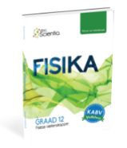
FISIESE WETENSKAPPE (Chemie Handboek 1):  DocScientia Chemie Grade 12 Hand- en Werkboek 1 (2020 Weergawe) | Bestel direk by DocScientia. Bestel vorms is beskikbaar by:  https://www.docscientia.co.za/afr/index.php/home-page  Nota: Al drie handboeke kan bestel word as ‘n bundel. Handboeke is beskikbaar in kleur indien die student kleur handboeke verkies. | 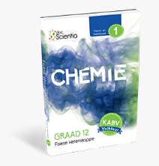
FISIESE WETENSKAPPE (Chemie Handboek 2):  DocScientia Chemie Grade 12 Hand- en Werkboek 2 (2020 Weergawe) | Bestel direk by DocScientia. Bestel vorms is beskikbaar by:  https://www.docscientia.co.za/afr/index.php/home-page  Nota: Al drie handboeke kan bestel word as ‘n bundel. Handboeke is beskikbaar in kleur indien die student kleur handboeke verkies. | 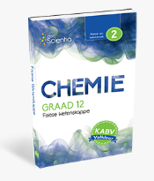

LIFE SCIENCES:  Gr 12 The answer series Life Sciences Part 1 CAPS | ISBN:  978-1-920568-84-9 | 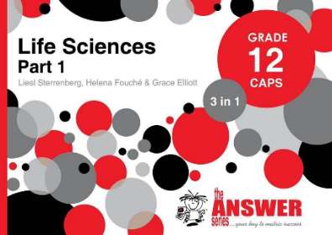
LIFE SCIENCES  Gr 12 The Answer Series Life Sciences Part 2 CAPS | ISBN:  978-1-920568-86-3 | 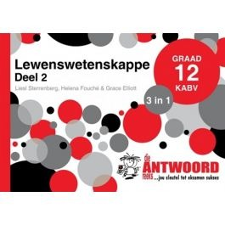
ACCOUNTING:  New Era Accounting grade 12  Learner’s book | ISBN:  978-1-77585-013-7 | 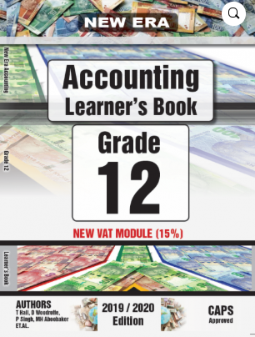
ACCOUNTING:  New Era Accounting grade 12  Exercise book 1 and 2 | ISBN:  978-1-77585-015-1 | 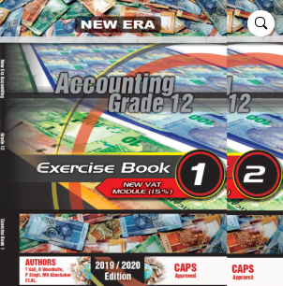
ACCOUNTING:  Advanced Accounting workbook Grade 12 | ISBN:  9780980273045 | 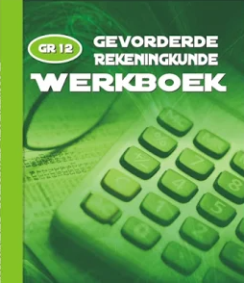
GESKIEDENIS:  Oxford Op soek na Geskiedenis Graad 12 Leerderboek | ISBN:  9780190412302
IGO:  JPEGD Engineering Graphics and Design. Grade 12 Workbook. (A3) 8th Edition | ISBN:  978-1-990957-83-3 | 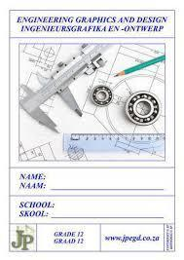
LEWENSORIëNTERING:  Spot On Life orientation | ISBN: 9780796236128 | 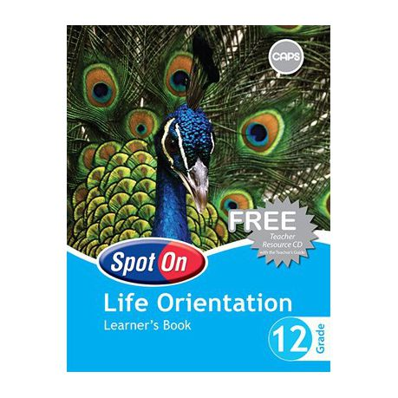
CAT:  Computers, part of your life grade 12 Second Edition | 978-0-6399049-4-8 | 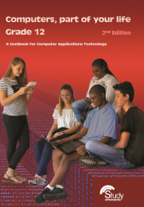
Visual Arts Grade 12 Learner Guide  English book | ISBN 9781775810087 | 